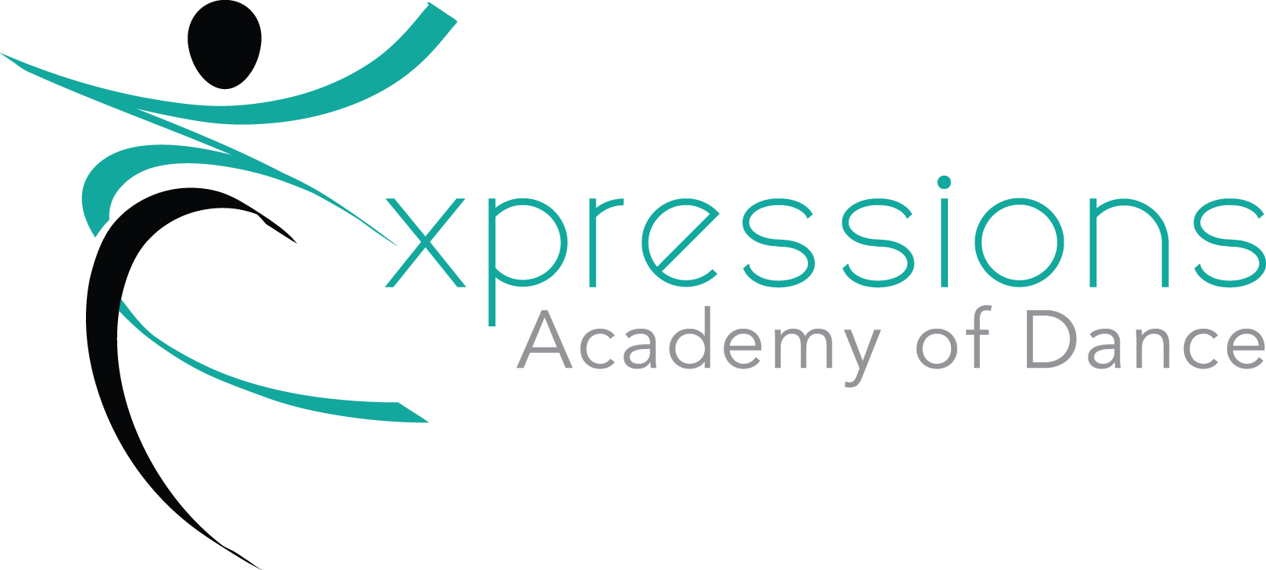

Expressions Academy of Dance
2023-24 Handbook

ATTIRE
**Appropriate Attire: NO Athletic Shorts or baggy shirts. NO JEANS. Hair must be pulled out of face.

**Predance and Mommy and Me: Movement friendly clothing (street clothes or dancewear), bare feet or ballet shoes.

**Level 1-5 Ballet: Leotard, tights and pink ballet shoes. Ballet skirts are permitted.

**Level 1-5 Tap/Jazz: Black tap shoes, Black jazz shoes. Leotard, tights, booty shorts, leggings, or jazz pants.

**Acro: Tight comfortable attire such as athletic shorts, leggings, and bare feet, hair pulled out of face. NO JEANS

ATTENDANCE AND PARTICIPATION
It is extremely important that students be on time and attend classes regularly. Please be aware that in order to improve and advance your dance skills you must be willing to fully participate in each and every class. Please call and leave a message to report any absence. 618-416-0297

MAKE UP CLASSES
If your student is unable to attend their regularly scheduled class due to illness, schedule conflict, etc. You may attend a comparable class during that week to make up for the class missed. All classes must be made up in the month dancer missed class. Classes will need to be made through the office due to limited class sizes.

LIABILITY DISCLAIMER
All students and parents are required to sign a medical release form absolving EAD from liability in the case of emergency. We also require a medical emergency number to be on file for each student.

LEAVING THE STUDIO
Students are strictly prohibited to sit outside the studio alone. If students go outside for any reason, they must have permission of a staff member. All classes will be brought to main door at end of class, we do not allow students to leave the deck without a parent present. Parents can wait outside or in the car and walk up to deck to meet their child at end of class.

WAITING ROOM/WATCH WEEK
We have a small waiting room just inside the main entrance. This is mainly for dropping off/picking up. We have found that children do much better in class without parents in the studio. There is a TV screen with live video of each studio if you would like to check on them. We will have watch week on last week of each month during the last 5 minutes of each class. Parents are invited into the studio to see what the dancers have been working on in class.

SICK POLICY
If a student is sick or has a fever, we prefer that he/she not attend class. Please inform the studio and talk to your teacher for a makeup class if needed. Refunds will not be given as we are holding your dancers spot in class, but makeup options will be offered after they return.

HOLIDAYS and WEATHER CLOSINGS
In the event of bad weather, please check the web site, Facebook, or call the studio.
We do not always follow the local schools closing. Many times schools are closed and we will still have evening classes because the rods are clear by evening.

November 22-November 26th- Closed for Thanksgiving
Dec 19th -Jan 1st - Closed for Christmas Break
March 25th- March 31st^{th} - Closed for Spring Break
May 27th- Closed for Memorial Day

SANTA PARADE 2023
All Expressions students are invited to participate in the Santa Parade in Belleville Il on November 24th, 2023. This is optional , Age 6 and up are invited to dance and will need a costume. We usually have a float and the younger dancers are invited to ride. These costumes will be ordered by October 1st and cost is $70. Separate practices will be held for this parade. Please watch Facebook and email for more information.

CHRISTMAS PROGRAM 2023- TBD
All recreational classes will have a performance in the Holiday Show in December.

RECITAL 2024 (Tentative)
Each and every dance class will learn a dance to perform in the spring recital which is June 15-17, 2023. Each class will have a costume ordered by Feb 1st. The recital is not mandatory, but it is a goal the students look forward to achieving all year. Remember: If you do not intend to participate in the recital, you must inform us in writing by December 1st, otherwise your account will be assessed a nonrefundable recital fee. Any dancer holding an overdue balance at the time of recital will not be allowed to participate in the recital. Recital Pictures are tentatively scheduled for June 13-15th 2024

COSTUME INFORMATION (Tentative)
For us to get all costumes in time for spring recital, we need to place orders early. Recital Costume Deposits will be due on Dec 1st and are non-refundable.
2023 Costume Fees are as follow….
Pre Dance and Mommy/Daddy and Me- $70
Level 1 Tap/Ballet will be $100- this will be a 2 in 1 costume
Level 2 Tap/Ballet will be $100- this will be a 2 in 1 costume
Level 3 Tap/Ballet will be $100- thus will be a 2 in 1 costume
Acro, Jazz, Hip Hop- $75 Per Costume

RECITAL FEE
There is a $65 recital fee per family paid by all students who wish to participate in our dance recital. This fee includes 4 tickets per family. Additional tickets will be for sale at a later date. This fee will be due by March 1st. The fee covers renting the venue, operation costs such as lights, props, music, etc., administrative costs and much more.

OFFICE HOURS
An EAD representative will be available in the office located through the main Grey entrance to answer your question and phone calls from 5-8pm, Monday thru Thursday evenings. If you are unable to contact us during regular office hours, feel free to leave a message, email or Facebook message us. A mailbox is located outside the main entrance for tuition checks if office is closed.

STUDIO RULES
- No food, gum or drinks besides water is allowed in the studios.
- To help avoid injury, please arrive on time to class for proper warm up. If you are more then 15 min late, you may be asked to observe
- Promotions to higher class levels will be decided by the teacher by invitation or audition
- If a student causes damage to the studio, the student/parent will be held responsible. Please note the ballet barres are not to be hung on.
- If a student is being disruptive, they may be excused for the remainder of the class.
- Dance shoes should never be worn outside! Staff will be available to change shoes in-between classes if necessary.
- Water bottles can be purchased for $1 from the office (sorry no more IOUs). Dancers can also bring their own disposable water bottle (ONLY) clearly marked with their name. No other food/Drink will be permitted.

TUITION
Tuition is due by the 10th of each month. Any tuition outstanding after the due date will be subject to a $25 late fee. Every month is the same amount of tuition regardless of how many weeks are in the month. Our tuition is spread out through the 10 months of the year and remains the same from Sep-June. You may pay tuition by cash or check into the drop box at the grey entrance or through dance studio pro. Automatic withdrawal is also available and must be signed up by the parent through Dance Studio Pro.

